**APPLICATION LETTER**

**1. Kepala Surat (Heading)**

Informasi ini diletakkan pada urutan teratas dalam surat lamaran kerja. Bagian ini berfungsi agar surat lamaran tersebut jelas ditujukan kepada siapa. Di sini, jangan lupa untuk tulis nama dan alamat perekrut.

**2. Salam Pembuka (Opening Greeting)**

Setiap surat biasanya akan diawali dengan salam pembuka. Poin ini penting untuk menunjukkan interaksi pada perekrut secara tidak langsung.

**3. Paragraf Pembuka (Introductory Paragraph)**

Lalu lanjut pada paragraf pembuka. Di bagian ini, kamu bisa menuliskan terkait maksud/tujuan utama dari surat. Bisa diisi dengan kalimat misalkan: “Bersamaan surat ini, saya bermaksud melamar pekerjaan di posisi Marketing sesuai dengan informasi lowongan yang ada di website abd.com”,

Contoh lain, “Berdasarkan informasi lowongan kerja yang saya lihat di Instagram @lokerbandung, saya bermaksud untuk melamar kerja di perusahaan yang Bapak/Ibu pimpin sebagai Social Media Specialist.”

**4. Paragraf Inti (Highlighting Paragraph)**

Pada isi surat, jangan ragu untuk menuliskan perkenalan diri secara singkat dan jelas. Mulai dari latar belakang pendidikan, pengalaman bekerja/kursus yang pernah kamu jalani, dan hal-hal lain yang relevan dengan posisi tujuan.

Pastikan agar perkenalanmu tidak terlalu panjang, dan jangan sertakan pengalaman-pengalaman yang sama sekali tidak *relate* dengan posisi yang kamu lamar. Selain itu, kamu juga bisa menjelaskan potensi yang dimiliki, serta memaparkan karakter positif dalam dirimu.

**5. Paragraf Penutup (Closing Paragraph)**

Di paragraf ini, sampaikan kalimat yang menyatakan maksud dan tujuanmu untuk melamar, selain itu buat kesimpulan bahwa kamu adalah kandidat yang tepat untuk mengisi posisi berdasarkan kemampuan atau pengalaman yang dimiliki.

**6. Salam Penutup (Complimentary Close)**

Selanjutnya, sampaikan salam penutup untuk melengkapi surat lamaran.

**7. Tanda Tangan (Signature)**

Setelah itu, akhiri surat dengan tanda tangan dan nama terang.

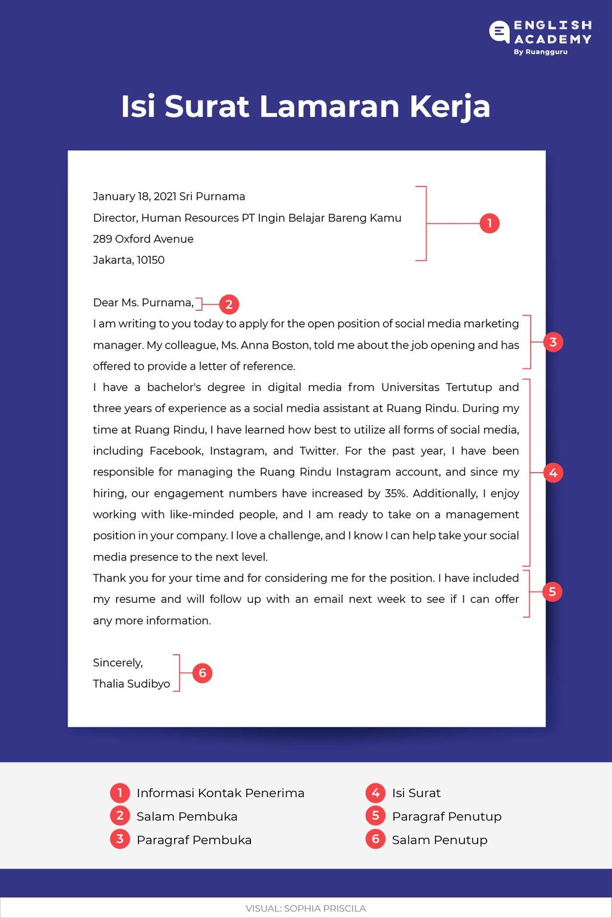

Contoh paragraf pembuka dalam *cover letter*:

“*I’d like to officially apply for the brand marketing strategy position at Technician Company as informed on LinkedIn. Over the past 5 years, I’ve worked with 20 clients, helping them drive more than $8,000,000 worth of sales. I am confident that my marketing skills and proven sales results make me a perfect match for the position.”*

* **Contoh yang fokus pada pencapaian:**  
  *“I’ve succeeded in consistently selling products that perform 20% higher than baseline. In 2020, I was awarded Best Employee for my efforts. With my skill set, I’d be a strong asset at Ruang Rindu, and significantly contribute to the team’s success.”*
* **Fokus pada pengalaman:**  
  *“I have over seven years of experience working in the performance marketing space. In my current role at Gogo Driving, I was able to implement new email campaigns centered around re-engaging churned clients.”*

**Contoh paragraf penutup menggunakan bahasa Inggris:**

*“Thank you for spending the time to review my application. I deeply believe that my skills and qualifications make me an ideal candidate for the 5th grade science teacher position at Neuron Academy. I’m extremely motivated to join your school, and look forward to discussing my candidacy in an interview.”*

**Salam penutup**

Akhiri surat menggunakan salam penutup alias *signature*dan nama jelas. Contoh *signature* dalam *cover letter* adalah:

*Sincerely,  
Erlangga Wicaksana*

Selain *sincerely*, kamu juga bisa menggunakan *best regards, warm regards,*atau *sincerely yours*.

**Lampiran apa saja yang harus ada dalam surat lamaran kerja?**

* Curriculum Vitae (CV) atau Resume
* Foto copy KTP
* Pas foto ukuran 3×4
* SKCK (Surat Keterangan Catatan Kepolisian)
* Surat Keterangan Kerja (SKK) atau Surat Pengalaman Kerja
* Foto copy Transkrip Nilai atau Ijazah Terakhir
* Sertifikat Pelatihan atau Kursus
* Portfolio atau Portofolio

**Contoh Surat Lamaran Kerja**

|  |
| --- |
| *30 February, 2020*  *Jacob Handaya Human Resources Manager Ruang Rindu Pte Ltd Head Office Zip Code 321 Employment St. Singapore*  *Dear Mr. Handaya,*  *I saw the job vacancy advertisement on LinkedIn. Through this letter, I would like to express my interest in the PM position at your company. I have* *a highly skilled project manager with 8 years of experience. My experience aligns well, as I have worked in project management for several years, and I know I would make a valuable addition to your team.*  *After working for nearly a decade in project management, I have advanced knowledge in developing scopes, keeping projects moving, submitting deliverables on time, and ensuring a seamless experience for all parties involved. Besides that, while my previous position afforded me a well-rounded skill-set, and time efficiency skills, I excel at:*   * *Planning and executing project scopes, managing timelines, and deadlines.* * *Tracking and reporting on overall progress.* * *Manage daily operations of brand new programs and metric the objective.* * *Predict project revenue and ensure all goals are met.*   *In addition to my experience and relationship-building experience, I have a solid educational foundation, a critical person, a disciplined person, excellent communication skills, and a passion for furthering projects that build loyalty, and in turn, will grow revenue for your organization. I very much appreciate the opportunity to contribute to your ongoing growth and continued success.*  *Thank you for reviewing my attached application for additional details regarding my expertise and achievements. Don’t hesitate to reach out to me by WhatsApp at 1234567889 or email at joniiskandar@gmail.com if you have any questions or need further clarification on my experience.’ i would love to meet with you and discuss this position in detail.*  *Thank you for your attention.*  *Sincerely, Joni Iskandar* |

**Contoh Lamaran Kerja Bahasa Inggris Untuk *Fresh Graduate/*Tanpa Pengalaman**

|  |
| --- |
| *Mrs. Shabrina Zatalini Talent Acquisition PT Bintang Infrastruktur Utama 234 Sudirman Business District Center Salemba Baru, South Jakarta, 12190*  *Dear Mrs. Zatalini,*  *Based on the information I received from one of the job seeker platforms on March 12 2022, your company is hiring for Geologist and I am very interested in this job.*  *My educational background is a bachelor’s degree of Science in Geology Engineering, Bantul State University. I had many practical experiences and exposure during my study. I have acquainted myself with a range of skills that would allow me to blend with your corporation.*  *From your vacancy, I can see that you are looking for candidates who have excellent skills that are relevant to geo-environmental engineering. I have a thorough knowledge of the processes of construction in ground exploration projects, and drilling systems and also excellent Interpersonal and communication skills. So, I think the job description for that position matches my last education.*  *Along with the cover letter, I have already attached the documents; Curriculum vitae, last diploma, and health record certificate for your full consideration. Don’t hesitate to contact me via email at bryanbri@gmail.com if you have any further questions. I appreciate your time reviewing my application, and I really hope to get a chance to the next stage and give a positive contribution to your company.*  *Thus this job application letter I made truthfully. Thank you for your attention.*  *Respectfully, Bryan Nurliansyah* |

|  |
| --- |
| *Jakarta, November 20, 2021*  *Yasrudin Muhammad Head of People Partner PT Ramah Anugerah Perkasa Cempaka Putih RT 09 RW 10, Bantarjati, North Bogor Bogor, Indonesia, 1245*    *Dear Mr. Muhammad,*  *I am writing this letter to apply for the position in Customer Service as advertised on your Twitter account and retweeted by the @hrdbacot account. I’m interested to join your company because this exciting opportunity appears to be an incredible fit with my professional experience, personal interest, and career goals. I have an educational background from Communication and Islamic Broadcasting, State Islamic University of Sunan Gunung Djati, Bandung with a 3.67 cumulative GPA. I come from a solid communication background with an interest in public relations and writing.*  *Having spent six months in my last internship experience, I am eager to incorporate myself into a startup that provided a position for customer relations or content writing. I am incredibly sure that the knowledge and experiences such as having a nice EQ, technology savvy, a good command of communication & writing, and being located out of Jabodetabek will fit with this position. Also, I have been active in some organization and community that has the same approaches to my skills. I am a fast learner, looking for a challenge, and curious. I believe my academic background, professional work, and internship experiences could bring a positive impact and contribution to your company.*  *I have attached my resume, and I would appreciate the opportunity to interview and discuss this position with Mr. Muhammad. Please find enclosed my resume for your review. I am readily available via email at ratnasegarasanusi@gmail.com or can be reached by phone at +6822 4042 5518. Please do not hesitate to contact me if you have any questions.*  *Thank you so much for your attention, and I look forward to hearing from you soon.*    *Sincerely, Ratna Segara Sanusi* |